User’s Manual

for

Version 1.0

A product of the DIA-ASA Biopharm Working Group

Table of Contents

**Introduction** 3

**eDISH Graphic Features** 4

Messages 4

Settings 5

Filters 6

**Hepatotoxicity Evaluation Workflow** 7

**Hy’s Law Quadrant Evaluation** 9

**Step 1** 9

**Step 2a** 12

**Step 2b** 15

**Step 2c** 17

**Step 2d** 19

**Step 2e** 21

**Step 3** 22

**Temple’s Corollary Quadrant Evaluation** 24

**Step 4** 24

**Step 5a** 27

**Step 5b** 29

**Step 5c** 31

**Step 5d** 33

**Step 5e** 35

**Step 6** 36

**Hyperbilirubinemia Quadrant Evaluation** 38

**Step 7** 38

**Step 8a** 41

**Step 8b** 43

**Step 8c** 45

**Step 9** 46

**References:** 47

# **Introduction**

Early specific indicators of drug-induced hepatic injury include elevations of hepatic transaminases and total bilirubin. However, the diagnosis of drug-induced liver injury (DILI) is one of exclusion, having excluded other possible causes of the laboratory and clinical abnormalities. As first proposed by Dr. Hyman Zimmerman (1978) based on clinical presentation, and subsequently refined by FDA as an evaluation of biomarkers, the concept of “Hy’s Law” became adopted as a means to identify instances indicative of the potential for DILI. The predictive value of Hy’s Law has been validated by studies in Sweden (Bjornsson & Olsson 2005) and Spain (Andrade et al. 2005). Dr. Ted Guo, a statistician at FDA, was the first to develop a graphical tool to screen laboratory datasets for elevations of transaminases and bilirubin that met the definition of possible Hy’s Law cases; the application was called eDISH for evaluation of drug-induced serious hepatotoxicity (Senior 2014). This approach to the graphical display of hepatic laboratory data has subsequently been adopted by safety specialists in industry and academia.

The DIA-ASA Biopharm Working Group is interested in developing new interactive tools that expand upon the static nature of existing graphics, such as eDISH. Beyond just a tool for signal detection, the interactive tool would also provide data exploration capabilities to facilitate signal evaluation. This interactive safety graphic of the eDISH plot builds upon the traditional static eDISH graph to afford customization of the analysis and the ability to explore cases that appear in each of the quadrants of interest: potential Hy’s Law cases, Temple’s corollary cases and isolated hyperbilirubinemia cases. For each such case of interest, the underlying data can be evaluated for evidence supporting or discounting a contributory role by the drug of interest. This user’s manual provides not only instructions concerning the features of this tool, but also a suggested workflow for evaluating the characteristics of any cases meeting the conditions for a potential Hy’s Law case, a case of Temple’s Corollary or a case of hyperbilirubinemia. Each of the suggested evaluation steps is accompanied by information supported by the medical literature concerning how to interpret the findings of each evaluation. The user is also referred to the FDA’s guidance document for a review of their approach to evaluating signals of potential DILI (FDA 2009).

For instructions on how to how to download and install the app on your computer, please refer to: <https://github.com/ASA-DIA-InteractiveSafetyGraphics/safetyGraphics/wiki/Vignette:-Shiny-User-Guide>.

# **eDISH Graphic Features**

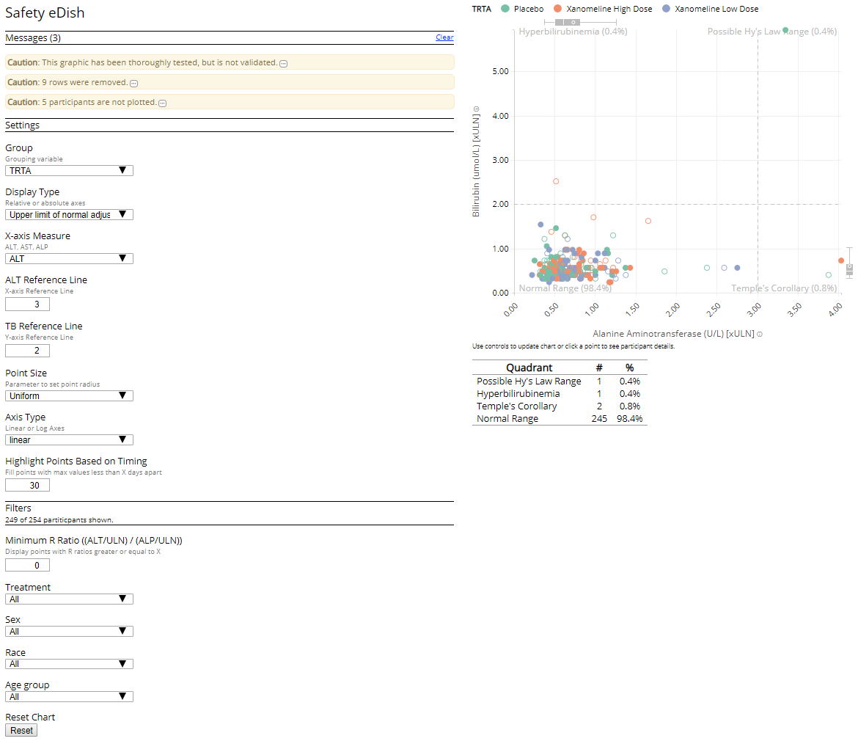

## Messages

When the interactive eDISH graphic is launched the system will display relevant messages. The first message is a standard caution that this tool has not been formally validated; as such it is intended for exploratory purposes only. Decisions based upon these analyses to define product risks should be based on replicated analyses using the sponsor’s internal validated tools and standard operating procedures.

Additional messages can include cautions concerning the dataset in use. Details of each of these can be accessed by clicking on the  icon.

## Settings

**Group**: The data can be displayed by colors denoting any of three groupings: Treatment (TRTA), Race (RACE) and Age Group (AGEGP1). If None is chosen, the subjects are not grouped by any parameter and all points have the same color.

**Display Type**: The display type defines how the X and Y axes are presented in terms of fold change from a reference point. The standard eDISH display is to present the transaminase and bilirubin data as fold change from the upper limit of normal for each respective laboratory value. The alternative mDISH approach is to display the laboratory data as the fold change from the patient’s baseline for that variable. The default baseline for each laboratory value is based on DY == 0, but the user can specify the column and value(s).

**X-axis Measure**: The measure of the X-axis can display ALT, AST or alkaline phosphatase. Standard eDISH displays utilize one or both or the transaminases. Alkaline phosphatase is included as a choice to further explore the data.

**ALT Reference Line**: The ALT reference line (X-axis reference line) defaults to 3, the standard threshold for the eDISH graph. However, there are certain circumstances in which the user may wish to change the threshold. This can be accomplished by either entering a new value into the box or, alternatively, by using the mouse to drag the line on the graph to the desire value.

**TB Reference Line**: The total bilirubin reference line (Y-axis reference line) defaults to 2, the standard threshold for the eDISH graph. However, there are certain circumstances in which the user may wish to change the threshold. This can be accomplished by either entering a new value into the box or, alternatively, by using the mouse to drag the line on the graph to the desire value.

**Point Size**: The size of the points displayed in the graph can be changed from the default of a uniform point size to one based on the value of 4 other laboratory values: ALT, AST, alkaline phosphatase and bilirubin. The larger the value of one of these variables, the larger the point size. This can provide additional qualitative data to the graph. For example, while displaying ALT on the X-axis, setting the point size based on the AST value can provide useful information as to the extent to which AST elevations coincide with ALT elevations. Similarly, if the point size is based on the alkaline phosphatase variable, the user can have a sense of the extent to which elevated ALT/bilirubin values may be associated with evidence of cholestasis.

**Axis Type**: The format of the X and Y axes can be changed from the default of a linear axis to a log axes. Using a log axis can sometimes be useful to identify far outliers.

**Highlight Points Based on Timing**: The time interval between peak transaminase and total bilirubin values is an important aspect in the evaluation process, as will be described in more detail below. The user can identify cases where the peak values occur with a predefined time period. The default is 30 days; that is, the case is displayed as a filled circle when the peak transaminase and peak total bilirubin values occur within 30 days. A shorter time period can be utilized, such as 14 days, in which only cases with peak values within 14 days will be displayed as filled circles. Alternatively, a longer time window can be defined. Cases in which the peak value occur outside this time window are displayed as open circles.

## Filters

When a filter is applied, the graph indicates how many of the total population of patients is represented in the display.

For example: 

**Minimum R Ratio (ALT/ULN)/(ALP/ULN):** The R Ratio is a tool to evaluate the extent to which ALT elevations may be related to a cholestatic process versus an hepatocellular one. The graph can be filtered to a value equal to or exceeding a threshold set by the user.

**Treatment**: Depending on the what treatments are defined in the dataset, the display can be filtered to include only one of the available treatment arms. When “All” is selected, there is no filtering based on treatment assignment.

**Sex**: The data can be filtered to display only female (F) or male (M) patients. When “All” is selected, there is no filtering based on sex.

**Race**: Depending on how race is defined in the dataset, the display can be filtered to include only one of the available racial types. When “All” is selected, there is no filtering based on race.

**Age Group**: The data can be filtered based on 3 age groups: <65 years, 65-80 years and >80 years. If other age ranges are required, these altered by reconfiguring the code. When “All” is selected, there is no filtering based on age group.

**Reset Chart**: After an adjustment is made on any of the above parameters, the user can return to the default state by clicking on the reset button: 

# **Hepatotoxicity Evaluation Workflow**

The diagnosis of drug-induced liver injury is one of exclusion, where it is important to first identify possible confounding factors giving rise to elevations in transaminase and total bilirubin levels before concluding that exposure to the drug of interest has resulted in hepatoxicity. A number of such evaluations can be conducted within the current version of the interactive eDISH graphic. The following flow diagram illustrates a proposed method of working through important analyses that will gather data that supports or discounts a causal role for the drug of interest. At the conclusion of the workflow, and with the consideration of additional data elements, the user will be in a better position assess the extent to which the drug of interest contributed to the observed laboratory abnormalities.

The workflow consists of a number of decision steps and suggested evaluations. For each evaluation, a discussion of the rationale and means of interpreting the results is provided based on the medical literature and best practices.

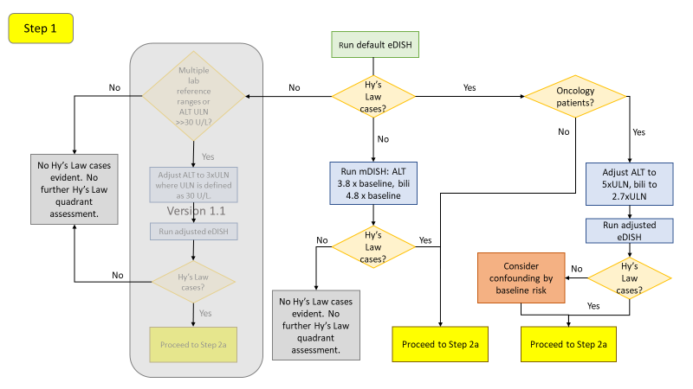

Note: The grayed-out portion is not available in Version 1.0 but is intended to be included in Version 1.1.

# **Hy’s Law Quadrant Evaluation**

## **Step 1**

|  |  |
| --- | --- |
| **Hy’s Law cases?** | **No**: After loading the dataset of interest, allow the tool to plot the eDISH results using the default settings. If no cases appear in the upper right potential Hy’s Law quadrant, run an mDISH analysis. Patients may have clinically important changes in transaminase and bilirubin levels that don’t meet Hy’s Law definition when evaluated using the default fold-change from the upper limit of normal, particularly if patients begin drug treatment with relatively low values. The alternative is to perform the eDISH analysis on the basis of fold-change from baseline. The baseline-corrected approach, called mDISH (modified DISH), would be more sensitive to drug effects and is more consistent across laboratories (Ozer et al. 2010, Lin et al. 2012). However, baseline-corrected data may be less sensitive than ULN-corrected data in populations with baseline liver chemistry elevations such as chronic hepatitis or nonalcoholic fatty liver disease. For a generally healthy study population, the boundary thresholds in mDISH are recommended to be 3.8 x baseline for ALT and 4.8 x baseline for total bilirubin (Lin et al. 2012). Adjust the ALT Reference Line and the TB Reference Line fields accordingly.  If the mDISH analysis yields no potential Hy’s Law cases, then further analyses are not necessary. (Note this will change when the fold change from a fixed ULN function is implemented in Version 1.1)  If the mDISH analysis yields one or more potential Hy’s Law cases, proceed to Step 2a. |
|  | **Yes**: The appearance of cases in the potential Hy’s Law quadrant could be the result of underlying risk factors in the population under study. Proceed to the next decision step: Oncology Patients? |
| **Oncology patients?** | **No**: Proceed to Step 2a. |
|  | **Yes**: Oncology patients, particularly those with advanced disease, represent a population who often demonstrate elevated transaminase and bilirubin values at baseline due to extensive pretreatment and/or presence of liver metastases. Such patients may appear in the Hy’s Law quadrant of a standard eDISH plot without necessarily experiencing drug-induced liver injury. A review of oncology patients, with and without evidence of liver metastases, recommended adjusting the ALT and total bilirubin thresholds (Parks et al. 2013). In patients without liver metastases, set the ALT threshold to 4.8 x ULN and bilirubin to 2.5 x ULN. In patients with liver metastases, set the ALT threshold to 5.5 x ULN and bilirubin to 3.0 x ULN. In patients either with or without known liver metastases, set the ALT threshold to 5.0 x ULN and bilirubin to 2.7 x ULN. Set these values in the ALT Reference Line and the TB Reference Line fields.  If the adjusted eDISH thresholds result in the same potential Hy’s Law cases, proceed to Step 2a.  If the adjusted eDISH threshold result in the loss of cases from the potential Hy’s Law quadrant, consider that their initial appearance as potential Hy’s Law cases could have been the result of confounding by the underlying disease process. Proceed to Step 2a. |
|  | **Note:** Other conditions may result in elevations of transferases and/or bilirubin; e.g., right heart failure/hypotension, connective tissue disorders involving the liver, inflammatory bowel disease and use of total parenteral nutrition (Ozer et al. 2010). However, recommendations for adjusted ALT and bilirubin thresholds are not available for these situations. In the case of the ischemic hepatitis that develops with right heart failure, the elevation in bilirubin is due to unconjugated bilirubin in 24-81% of cases (Dunn et al. 1973), illustrating the utility of bilirubin fractionation. |

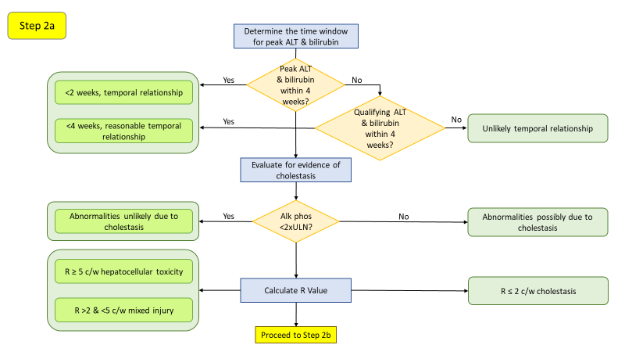

## **Step 2a**

|  |  |
| --- | --- |
| **Peak ALT and bilirubin within 4 weeks?** | **Yes**: Only elevations of bilirubin coincident with or shortly after peak ALT elevations are indicative of loss of hepatic function associated with liver injury (Merz et al. 2014). While there is no defined interval as a standard, peaks within 2 weeks are suggestive of DILI and up to 4 weeks may still indicate a drug effect. This can be assessed in the tool by defining the interval in the **Highlight Points Based on Timing** field**.** Alternatively, this can be manually reviewed by clicking on the point of interest in the Hy’s Law quadrant and review the individual ALT and total bilirubin graphs displayed below the eDISH graph for that patient. |
|  | **No**: Peak ALT and bilirubin values exceeding 4 weeks apart are less indicative of a drug-induced cause. |
| **Qualifying ALT and bilirubin within 4 weeks?** | A limitation of the eDISH graph is the use of peak values to define the position of cases within the graph. “Qualifying” values are those that exceed the ULN threshold for either ALT or total bilirubin, but don’t represent peak values (Merz et al. 2012).  **Yes**: Qualifying ALT and total bilirubin values occurring within 2 weeks of each other, and with the rise in bilirubin following the transaminase rise, are suggestive of DILI. While there is no defined standard interval, qualifying values within 4 weeks may still indicated a drug-related effect.  **No**: Qualifying ALT elevations exceeding 4 weeks apart are less indicative of a drug-induced cause. |
| **Alk phos <2 x ULN?** | **Yes**: A component of the Hy’s Law definition is the presence of transaminase and bilirubin elevation without initial findings of cholestasis (e.g., elevated alkaline phosphatase) (FDA 2009). The lack of an elevated alkaline phosphatase has been defined as <2x ULN (Avigan 2010). Transaminase and bilirubin elevations meeting Hy’s Law criteria in the absence of a concomitant elevation of alkaline phosphatase is indicative of hepatocellular injury.  **No**: An elevated alkaline phosphatase level coincident with transaminase and bilirubin elevations may indicate a cholestatic source of the bilirubin elevation which could discount drug-related hepatocellular damage. However, this does not remove the possibility of drug-related cholestatic injury.  **Note**: Alkaline phosphatase can be elevated by infiltrative diseases of the liver, tumors of hepatic and non-hepatic origin and bone diseases, including metastases to bone (AGA Clinical Practice Committee 2002). In such circumstances, these factors confound the ability to assess whether bilirubin elevations may be due to a cholestatic process. |
| **Calculate R value** | The R value (aka R ratio, R score) is calculated as [ALT/ULN]/[alkaline phosphatase/ULN] (Kullak-Ublick et al. 2017; Leise et al. 2014).  R > 5 indicates hepatocellular injury  R = 2-5 indicates mixed hepatocellular/cholestatic injury  R < 2 indicates cholestatic injury  A modified approach, called “new ratio” or nR, considers also the AST value in addition to the ALT value and uses whichever produced the highest fold change from the ULN (Robles-Diaz et al. 2014). Currently, this tool only calculates the R value based on ALT; calculation of the nR will need to be done manually at this time. |

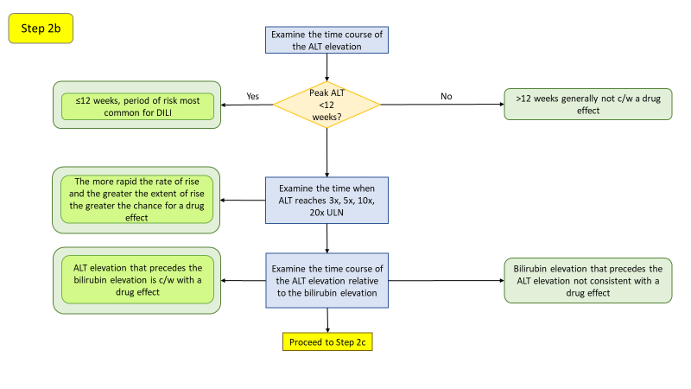

## **Step 2b**

|  |  |
| --- | --- |
| **Peak ALT <12 weeks?** | **Yes**: When evaluating the time course of the ALT elevation, the first 12 weeks from drug initiation is generally the period of greatest risk of drug-induced hepatotoxicity (Hunt et al. 2007). Elevations within the first couple weeks often reflect adaptation to drug load rather than an actual hepatotoxic effect, particularly when the daily dose is several hundred milligrams and higher. |
|  | **No**: Although instances of delayed hepatotoxicity have been reported, peak ALT levels in excess of 12 weeks is generally not consistent with a drug related effect. |
| **Examine the time when ALT reaches 3x, 5x, 10x and 20x ULN.** | Evaluating the time points at which various multiples of the ULN are reached (rate of rise) provides information on the acute nature of the reaction. The greater the rate of rise, the more acute the onset of the toxic effect suggestive of a drug-related effect. |
| **Examine the time course of the ALT elevation relative to the bilirubin elevation** | Only bilirubin elevations simultaneous with or soon after peak ALT elevations may indicate loss of hepatic function due to drug-induced liver injury. A time interval exceeding four weeks between both peaks may also speak against a causal correlation (Merz et al. 2014). |

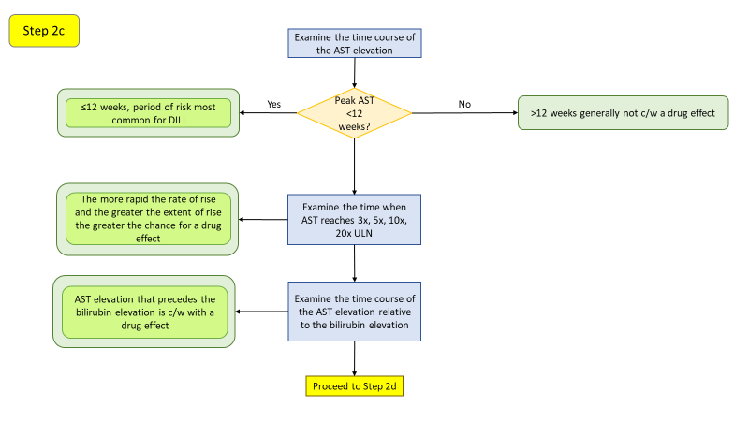

## **Step 2c**

|  |  |
| --- | --- |
| **Peak AST <12 weeks?** | **Yes**: Serum AST activity is considered a less specific biomarker of liver function compared to ALT as it also appears in heart, skeletal muscle, kidneys, brain and red blood cells. When evaluating the time course of the AST elevation, the first 12 weeks from drug initiation is generally the period of greatest risk of drug-induced hepatotoxicity (Hunt et al. 2007). Elevations within the first couple weeks often reflect adaptation to drug load rather than an actual hepatotoxic effect, particularly when the daily dose is several hundred milligrams and higher. |
|  | **No**: Although instances of delayed hepatotoxicity have been reported, peak AST levels in excess of 12 weeks is generally not consistent with a drug related effect. |
| **Examine the time when AST reaches 3x, 5x, 10x and 20x ULN.** | Evaluating the time points at which various multiples of the ULN are reached (rate of rise) provides information on the acute nature of the reaction. The greater the rate of rise, the more acute the onset of the toxic effect suggestive of a drug-related effect. |
| **Examine the time course of the AST elevation relative to the bilirubin elevation** | Only bilirubin elevations simultaneous with or soon after peak AST elevations may indicate loss of hepatic function due to drug-induced liver injury. A time interval exceeding four weeks between both peaks may also speak against a causal correlation (Merz et al. 2014). |

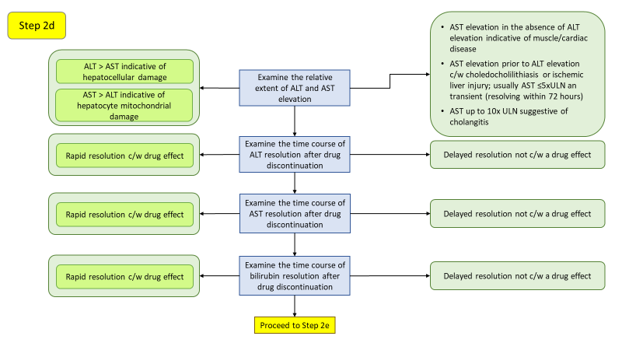

## **Step 2d**

|  |  |
| --- | --- |
| **Examine the relative extent of ALT and AST elevation** | ALT elevation that exceeds the AST elevation is indicative of principally hepatocellular damage, whereas an AST elevation in excess of ALT elevation can suggest hepatocyte mitochondrial damage. Approximately 80% of AST activity is from mitochondria (Thapa & Walia 2007). Acute alcoholic hepatitis and cirrhosis can present with an AST/ALT ratio of 2:1 (Yang et al. 2014), since alcohol is a mitochondrial toxin, but other mitochondrial toxins can also result in a disproportionate elevation of AST to ALT. A ratio of AST/ALT greater than five, especially if ALT is normal or slightly elevated, is suggestive of injury to extrahepatic tissues, such as skeletal muscle in the case of rhabdomyolysis or strenuous exercise (Woreta & Alqahtani 2014). |
| **Examine the time course of ALT resolution after drug discontinuation** | AST and ALT are catabolized in the liver, primarily by cells in the reticuloendothethlial system. The plasma half-life and ALT are 17± 5 hours and 47±10 hours, respectively. Thus, AST declines more rapidly than ALT, and ALT may be higher than AST in the recovery phase of injury (Woreta & Alqahtani 2014). Rapid resolution after drug discontinuation is consistent with a drug effect whereas a delayed resolution is not consistent with a drug effect. |
| **Examine the time course of AST resolution after drug discontinuation** | AST and ALT are catabolized in the liver, primarily by cells in the reticuloendothethlial system. The plasma half-life and ALT are 17± 5 hours and 47±10 hours, respectively. Thus, AST declines more rapidly than ALT, and ALT may be higher than AST in the recovery phase of injury (Woreta & Alqahtani 2014). Rapid resolution after drug discontinuation is consistent with a drug effect whereas a delayed resolution is not consistent with a drug effect. |
| **Examine the time course of bilirubin resolution after drug discontinuation** | Among subjects in a prospective study of DILI who had a total bilirubin ≥2.5 mg/dL, the median time from peak bilirubin to a 50% reduction was 14, 15 and 22 days in those with hepatocellular, cholestatic and mixed DILI, respectively and from peak bilirubin to <2.5 mg/dL was 30, 45 and 32 days in those with hepatocellular, cholestatic and mixed DILI, respectively (Chalasani et al. 2008). Time to resolution may be longer in elderly patients. |

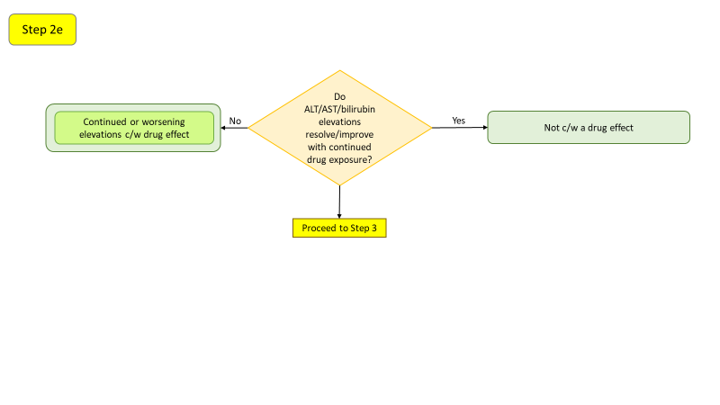

## **Step 2e**

|  |  |
| --- | --- |
| **Do ALT/AST/bilirubin elevations resolve/improve with continued drug exposure?** | A drug may initially result in elevations of hepatic analytes, but the elevations may resolve with continued therapy due to adaptation (Shapiro & Lewis 2007, Abboud & Kaplowitz 2007). Alternatively, the abnormalities may have been unrelated to the drug. |

**Additional Considerations**

|  |  |
| --- | --- |
| **Extent of hepatic metabolism** | Drugs with hepatic metabolism representing ≥50% of the elimination of the compound are more likely to be associated with ALT elevations ≥3 x ULN and liver failure (Lammert et al. 2010). Drugs metabolized via both Phase 1 (cytochrome P450 oxidation) and Phase 2 (conjugation) reactions have a higher propensity to cause ALT elevations ≥3 x ULN (Lammert et al. 2010). |
| **Extent of ALT elevation relative to placebo** | Moylen et al. (2012) reported that ALT elevations ≥3 x ULN that occurred in the study drug arm at a rate ≥1.2% greater than the placebo arm was associated with the subsequent development of a post-marketing EB05 score of ≥2 for liver-associated events with a positive predictive value of 71.4%. |

## **Step 3**

To be implemented in a future version.

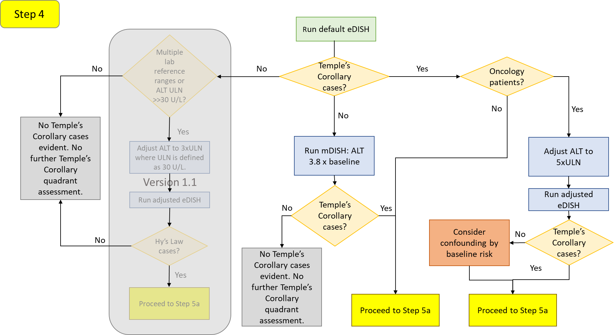

Note: The grayed-out portion is not available in Version 1.0 but is intended to be included in Version 1.1.

# **Temple’s Corollary Quadrant Evaluation**

## **Step 4**

|  |  |
| --- | --- |
| **Temple’s Corollary cases?** | **No**: After loading the dataset of interest, allow the tool to plot the eDISH results using the default settings. If no cases appear in the lower right Temple’s Corollary quadrant, run an mDISH analysis. Patients may have clinically important changes in transaminase levels that don’t meet Temple’s Corollary definition when evaluated using the default fold-change from the upper limit of normal, particularly if patients begin drug treatment with relatively low values. The alternative is to perform the eDISH analysis on the basis of fold-change from baseline. The baseline-corrected approach, called mDISH (modified DISH), would be more sensitive to drug effects and is more consistent across laboratories (Ozer et al. 2010, Lin et al. 2012). However, baseline-corrected data may be less sensitive than ULN-corrected data in populations with baseline liver chemistry elevations such as chronic hepatitis or nonalcoholic fatty liver disease. For a generally healthy study population, the boundary thresholds in mDISH are recommended to be 3.8 x baseline for ALT and 4.8 x baseline for total bilirubin (Lin et al. 2012). Adjust the ALT Reference Line field accordingly.  If the mDISH analysis yields no Temple’s Corollary cases, then further analyses are not necessary. (Note this will change when the fold change from a fixed ULN function is implemented in Version 1.1)  If the mDISH analysis yields one or more Temple’s Corollary cases, proceed to Step 2a. |
|  | **Yes**: The appearance of cases in the Temple’s Corollary quadrant could be the result of underlying risk factors in the population under study. Proceed to the next decision step: Oncology Patients?. |
| **Oncology patients?** | **No**: Proceed to Step 5a. |
|  | **Yes**: Oncology patients, particularly those with advanced disease, represent a population who often demonstrate elevated transaminase values at baseline due to extensive pretreatment and/or presence of liver metastases. Such patients may appear in the Temple’s Corollary quadrant of a standard eDISH plot without necessarily experiencing drug-induced liver injury. A review of oncology patients, with and without evidence of liver metastases, recommended adjusting the ALT threshold (Parks et al. 2013). In patients without liver metastases, set the ALT threshold to 4.8 x ULN. In patients with liver metastases, set the ALT threshold to 5.5 x ULN. In patients either with or without known liver metastases, set the ALT threshold to 5.0 x ULN. Set these values in the ALT Reference Line field.  If the adjusted eDISH thresholds result in the same Temple’s Corollary cases, proceed to Step 5a.  If the adjusted eDISH threshold result in the loss of cases from the Temple’s Corollary quadrant, consider that their initial appearance in that quadrant could have been the result of confounding by the underlying disease process. Proceed to Step 5a. |

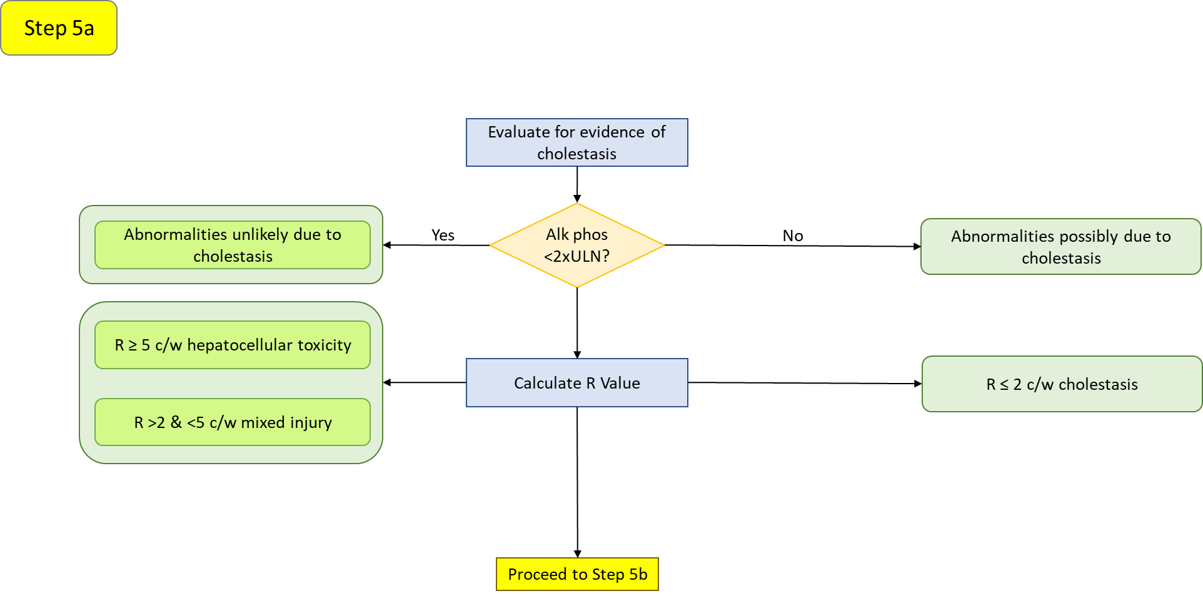

## **Step 5a**

|  |  |
| --- | --- |
| **Alk phos <2 x ULN?** | **Yes**: Transaminase elevations in the absence of a concomitant elevation of alkaline phosphatase may be indicative of hepatocellular injury. The lack of an elevated alkaline phosphatase has been defined as <2x ULN (Avigan 2010).  **No**: An elevated alkaline phosphatase level coincident with transaminase elevations may indicate a cholestatic source which could discount drug-related hepatocellular damage. However, this does not remove the possibility of drug-related cholestatic injury.  **Note**: Alkaline phosphatase can be elevated by infiltrative diseases of the liver, tumors of hepatic and non-hepatic origin and bone diseases, including metastases to bone (AGA Clinical Practice Committee 2002). |
| **Calculate R value** | The R value (aka R ratio, R score) is calculated as [ALT/ULN]/[alkaline phosphatase/ULN] (Kullak-Ublick et al. 2017; Leise et al. 2014).  R > 5 indicates hepatocellular injury  R = 2-5 indicates mixed hepatocellular/cholestatic injury  R < 2 indicates cholestatic injury  A modified approach, called “new ratio” or nR, considers also the AST value in addition to the ALT value and uses whichever produced the highest fold change from the ULN (Robles-Diaz et al. 2014). Currently, this tool only calculates the R value based on ALT; calculation of the nR will need to be done manually at this time. |

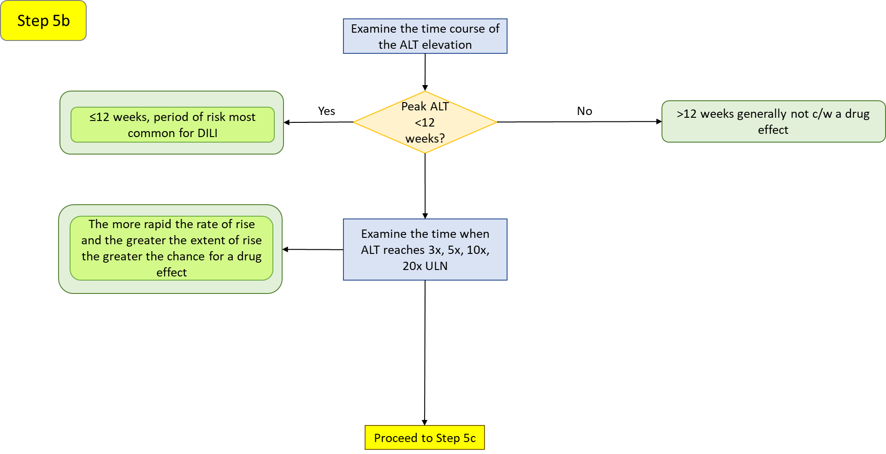

## **Step 5b**

|  |  |
| --- | --- |
| **Peak ALT <12 weeks?** | **Yes**: When evaluating the time course of the ALT elevation, the first 12 weeks from drug initiation is generally the period of greatest risk of drug-induced hepatotoxicity (Hunt et al. 2007). Elevations within the first couple weeks often reflect adaptation to drug load rather than an actual hepatotoxic effect, particularly when the daily dose is several hundred milligrams and higher. Note that acute hepatobiliary obstruction or inflammation, such as caused by a gallstone, can result in an abrupt rise in transaminases, bilirubin and alkaline phosphatase (Green & Flamm 2002). |
|  | **No**: Although instances of delayed hepatotoxicity have been reported, peak ALT levels in excess of 12 weeks is generally not consistent with a drug related effect. |
| **Examine the time when ALT reaches 3x, 5x, 10x and 20x ULN.** | Evaluating the time points at which various multiples of the ULN are reached (rate of rise) provides information on the acute nature of the reaction. The greater the rate of rise, the more acute the onset of the toxic effect suggestive of a drug-related effect. |

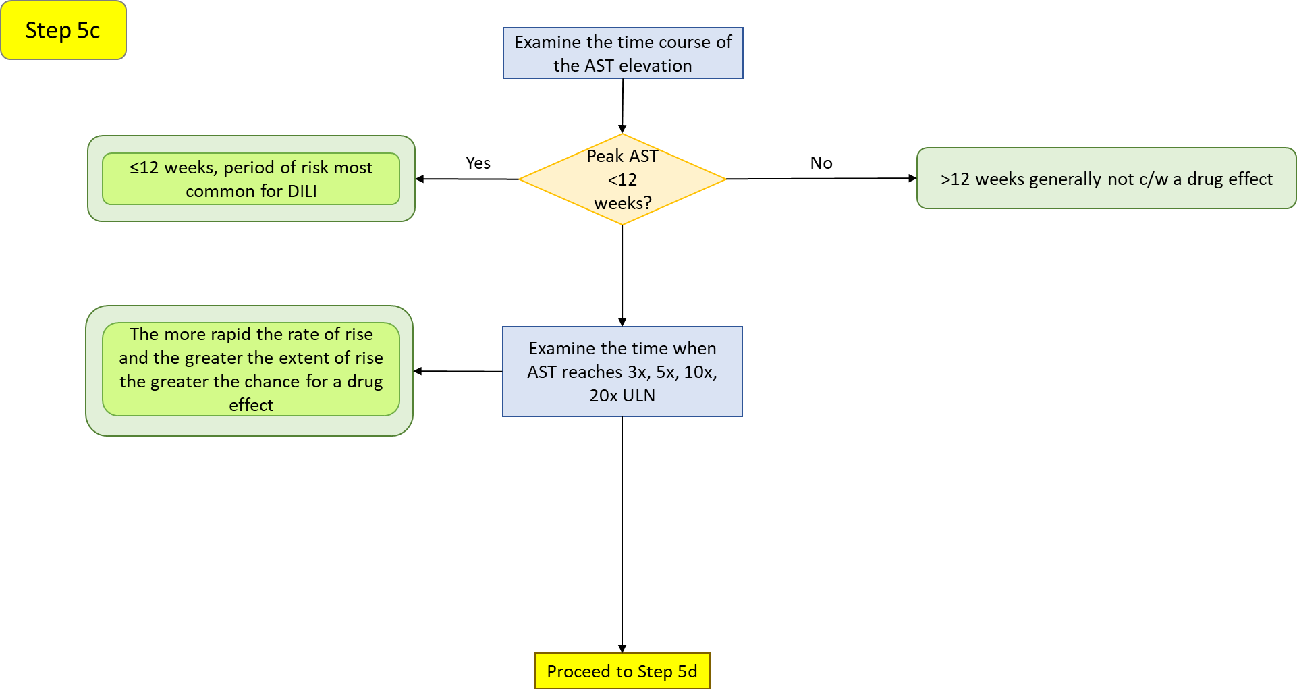

## **Step 5c**

|  |  |
| --- | --- |
| **Peak AST <12 weeks?** | **Yes**: Serum AST activity is considered a less specific biomarker of liver function compared to ALT as it also appears in heart, skeletal muscle, kidneys, brain and red blood cells. When evaluating the time course of the AST elevation, the first 12 weeks from drug initiation is generally the period of greatest risk of drug-induced hepatotoxicity (Hunt et al. 2007). Elevations within the first couple weeks often reflect adaptation to drug load rather than an actual hepatotoxic effect, particularly when the daily dose is several hundred milligrams and higher. Note that acute hepatobiliary obstruction or inflammation, such as caused by a gallstone, can result in an abrupt rise in transaminases, bilirubin and alkaline phosphatase (Green & Flamm 2002). |
|  | **No**: Although instances of delayed hepatotoxicity have been reported, peak AST levels in excess of 12 weeks is generally not consistent with a drug related effect. |
| **Examine the time when AST reaches 3x, 5x, 10x and 20x ULN.** | Evaluating the time points at which various multiples of the ULN are reached (rate of rise) provides information on the acute nature of the reaction. The greater the rate of rise, the more acute the onset of the toxic effect suggestive of a drug-related effect. |

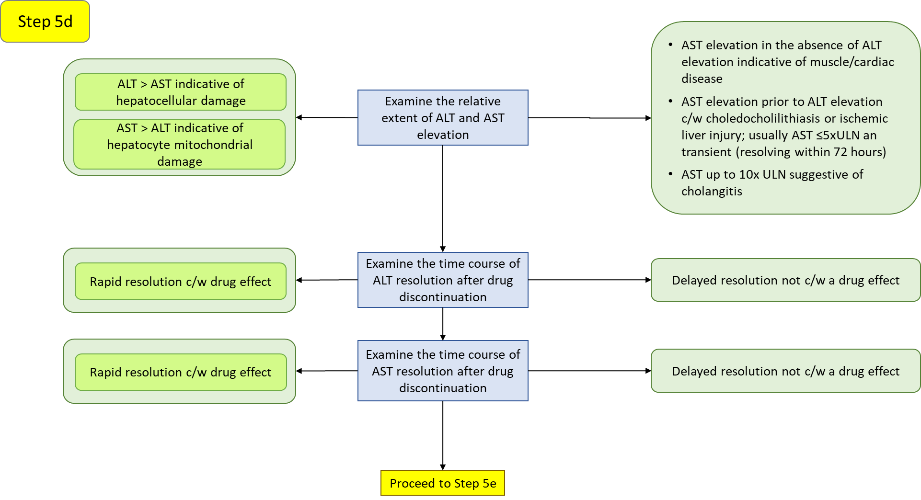

## **Step 5d**

|  |  |
| --- | --- |
| **Examine the relative extent of ALT and AST elevation** | ALT elevation that exceeds the AST elevation is indicative of principally hepatocellular damage, whereas an AST elevation in excess of ALT elevation can suggest hepatocyte mitochondrial damage. Approximately 80% of AST activity is from mitochondria (Thapa & Walia 2007). Acute alcoholic hepatitis and cirrhosis can present with an AST/ALT ratio of 2:1 (Yang et al. 2014), since alcohol is a mitochondrial toxin, but other mitochondrial toxins can also result in a disproportionate elevation of AST to ALT. A ratio of AST/ALT greater than five, especially if ALT is normal or slightly elevated, is suggestive of injury to extrahepatic tissues, such as skeletal muscle in the case of rhabdomyolysis or strenuous exercise (Woreta & Alqahtani 2014). |
| **Examine the time course of ALT resolution after drug discontinuation** | AST and ALT are catabolized in the liver, primarily by cells in the reticuloendothethlial system. The plasma half-life and ALT are 17± 5 hours and 47±10 hours, respectively. Thus, AST declines more rapidly than ALT, and ALT may be higher than AST in the recovery phase of injury (Woreta & Alqahtani 2014). Rapid resolution after drug discontinuation is consistent with a drug effect whereas a delayed resolution is not consistent with a drug effect. |
| **Examine the time course of AST resolution after drug discontinuation** | AST and ALT are catabolized in the liver, primarily by cells in the reticuloendothethlial system. The plasma half-life and ALT are 17± 5 hours and 47±10 hours, respectively. Thus, AST declines more rapidly than ALT, and ALT may be higher than AST in the recovery phase of injury (Woreta & Alqahtani 2014). Rapid resolution after drug discontinuation is consistent with a drug effect whereas a delayed resolution is not consistent with a drug effect. |

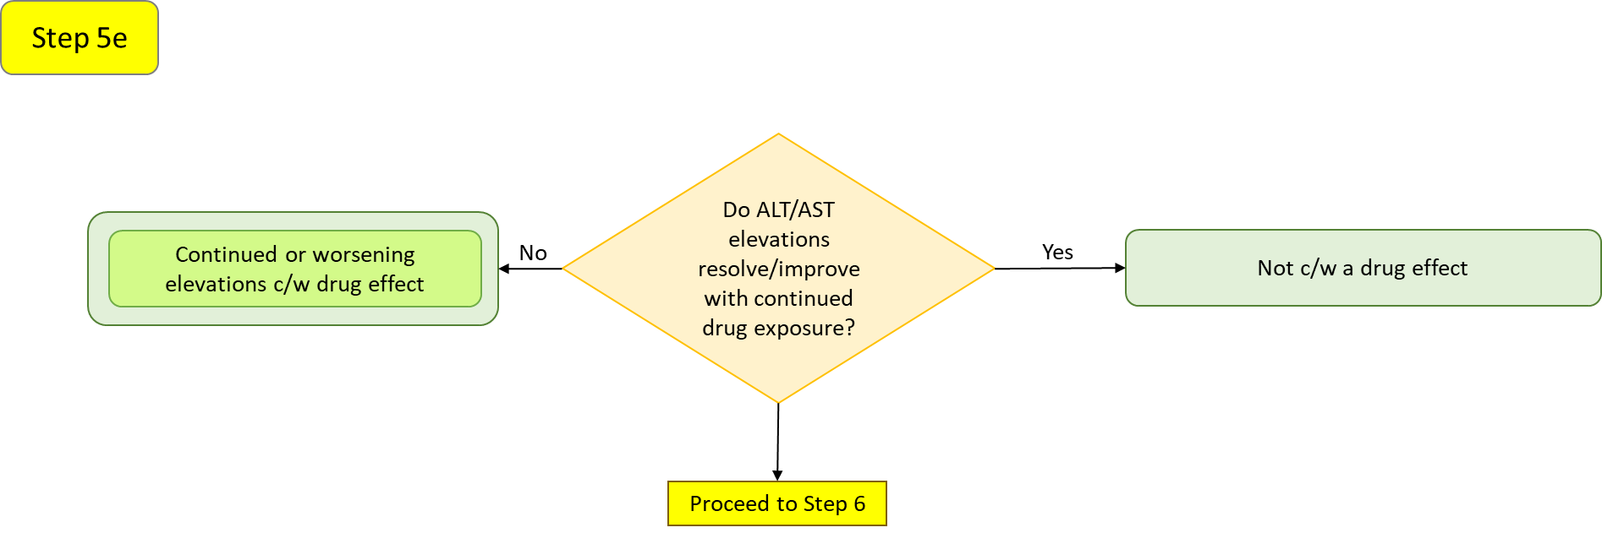

## **Step 5e**

|  |  |
| --- | --- |
| **Do ALT/AST elevations resolve/improve with continued drug exposure?** | A drug may initially result in elevations of hepatic analytes, but the elevations may resolve with continued therapy due to adaptation (Shapiro & Lewis 2007, Abboud & Kaplowitz 2007). Alternatively, the abnormalities may have been unrelated to the drug. |

**Additional Considerations**

|  |  |
| --- | --- |
| **Extent of ALT elevation relative to placebo** | Moylen et al. (2012) reported that ALT elevations ≥3 x ULN that occurred in the study drug arm at a rate ≥1.2% greater than the placebo arm was associated with the subsequent development of a post-marketing EB05 score of ≥2 for liver-associated events with a positive predictive value of 71.4%. |

## **Step 6**

To be implemented in a future version.

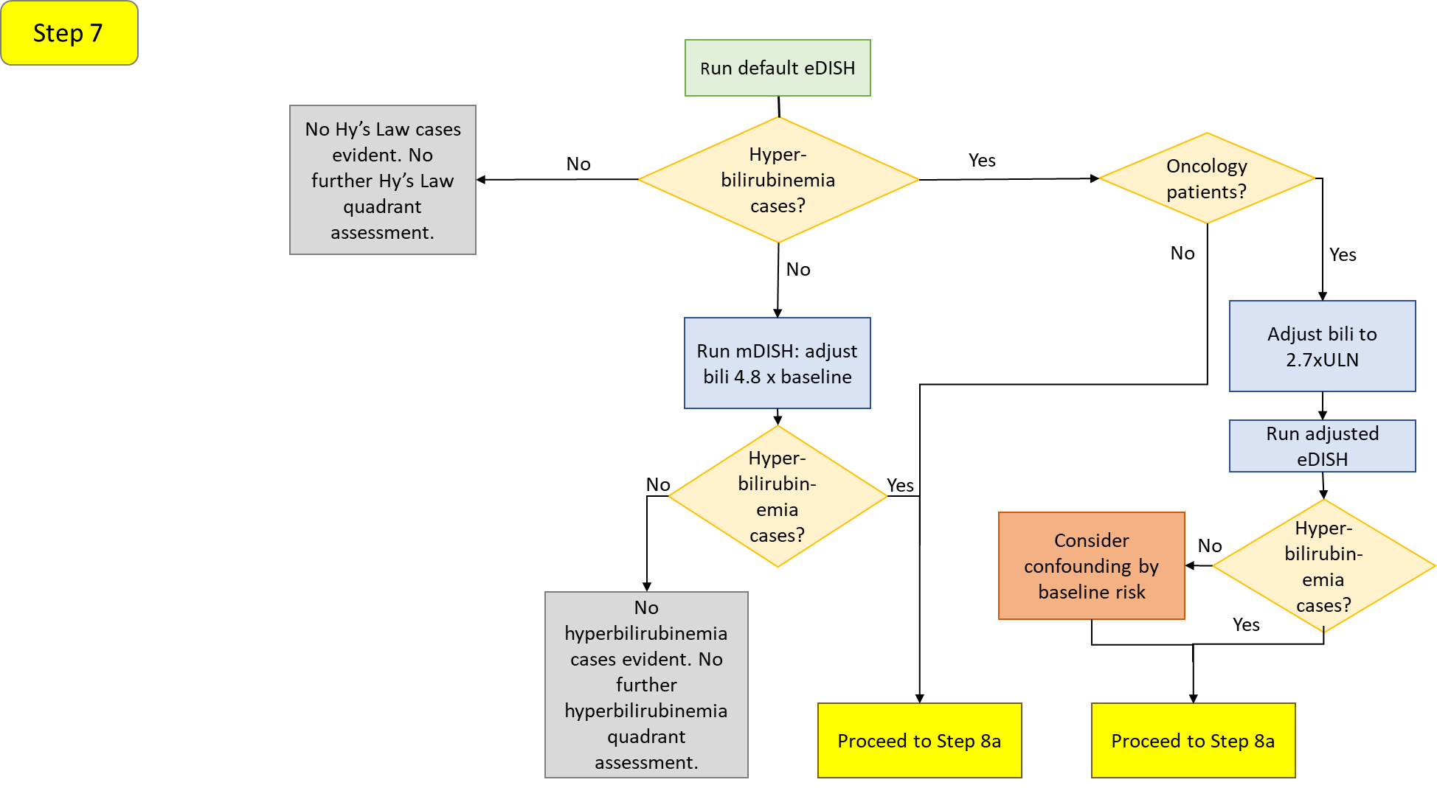

# **Hyperbilirubinemia Quadrant Evaluation**

## **Step 7**

|  |  |
| --- | --- |
| **Hyperbilirubinemia cases?** | **No**: After loading the dataset of interest, allow the tool to plot the eDISH results using the default settings. If no cases appear in the upper left hyperbilirubinemia, run an mDISH analysis. Patients may have clinically important changes in bilirubin levels that don’t meet hyperbilirubinemia definition when evaluated using the default fold-change from the upper limit of normal, particularly if patients begin drug treatment with relatively low values. The alternative is to perform the eDISH analysis on the basis of fold-change from baseline. The baseline-corrected approach, called mDISH (modified DISH), would be more sensitive to drug effects and is more consistent across laboratories (Ozer et al. 2010, Lin et al. 2012). However, baseline-corrected data may be less sensitive than ULN-corrected data in populations with baseline liver chemistry elevations such as chronic hepatitis or nonalcoholic fatty liver disease. For a generally healthy study population, the boundary thresholds in mDISH are recommended to be 4.8 x baseline for total bilirubin (Lin et al. 2012). Adjust the TB Reference Line fields accordingly.  If the mDISH analysis yields no hyperbilirubinemia cases, then further analyses are not necessary. (Note this will change when the fold change from a fixed ULN function is implemented in Version 1.1)  If the mDISH analysis yields one or more hyperbilirubinemia cases, proceed to Step 8a. |
|  | **Yes**: The appearance of cases in hyperbilirubinemia could be the result of underlying risk factors in the population under study. Proceed to the next decision step: Oncology Patients? |
| **Oncology patients?** | **No**: Proceed to Step 8a. |
|  | **Yes**: Oncology patients, particularly those with advanced disease, represent a population who often demonstrate elevated bilirubin values at baseline due to extensive pretreatment and/or presence of liver metastases. Such patients may appear in the hyperbilirubinemia quadrant of a standard eDISH plot without necessarily experiencing drug-induced liver injury. A review of oncology patients, with and without evidence of liver metastases, recommended adjusting the total bilirubin thresholds (Parks et al. 2013). In patients without liver metastases, set the bilirubin threshold to 2.5 x ULN. In patients with liver metastases, set the bilirubin threshold to 3.0 x ULN. In patients either with or without known liver metastases, set the bilirubin threshold to 2.7 x ULN. Set these values in the TB Reference Line fields.  If the adjusted eDISH thresholds result in the same hyperbilirubinemia cases, proceed to Step 8a.  If the adjusted eDISH threshold result in the loss of cases from the hyperbilirubinemia quadrant, consider that their initial appearance could have been the result of confounding by the underlying disease process. Proceed to Step 8a. |

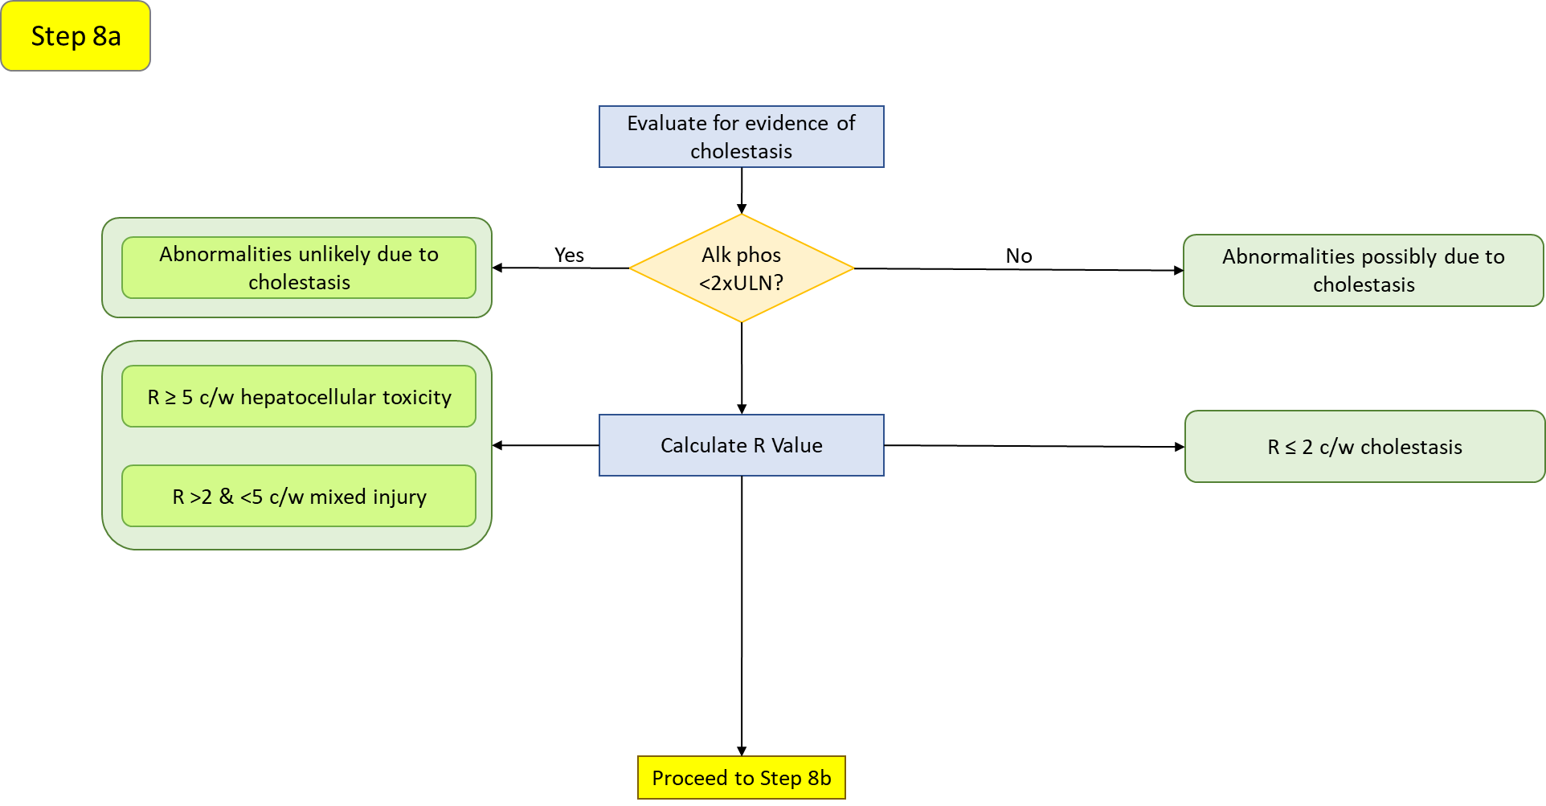

## **Step 8a**

|  |  |
| --- | --- |
| **Alk phos <2 x ULN?** | **Yes**: Bilirubin elevations in the absence of a concomitant elevation of alkaline phosphatase may be indicative of hepatocellular injury. The lack of an elevated alkaline phosphatase has been defined as <2x ULN (Avigan 2010).  **No**: An elevated alkaline phosphatase level coincident with bilirubin elevations may indicate a cholestatic source of the bilirubin elevation which could discount drug-related hepatocellular damage. However, this does not remove the possibility of drug-related cholestatic injury.  **Note**: Alkaline phosphatase can be elevated by infiltrative diseases of the liver, tumors of hepatic and non-hepatic origin and bone diseases, including metastases to bone (AGA Clinical Practice Committee 2002). In such circumstances, these factors confound the ability to assess whether bilirubin elevations may be due to a cholestatic process. |
| **Calculate R value** | The R value (aka R ratio, R score) is calculated as [ALT/ULN]/[alkaline phosphatase/ULN] (Kullak-Ublick et al. 2017; Leise et al. 2014).  R > 5 indicates hepatocellular injury  R = 2-5 indicates mixed hepatocellular/cholestatic injury  R < 2 indicates cholestatic injury  A modified approach, called “new ratio” or nR, considers also the AST value in addition to the ALT value and uses whichever produced the highest fold change from the ULN (Robles-Diaz et al. 2014). Currently, this tool only calculates the R value based on ALT; calculation of the nR will need to be done manually at this time. |

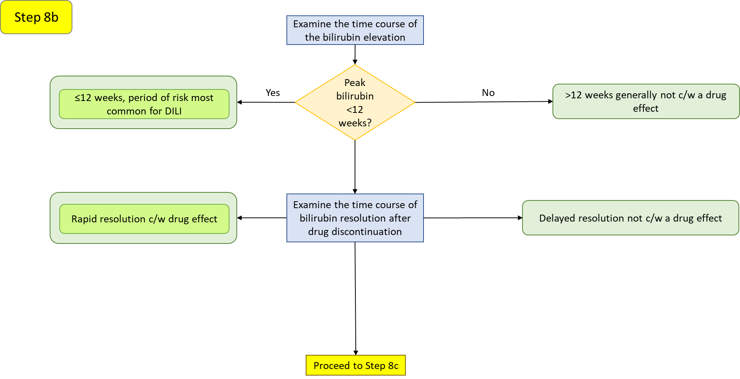

## **Step 8b**

|  |  |
| --- | --- |
| **Peak bilirubin <12 weeks?** | **Yes**: The period of greatest risk of drug-induced hepatotoxicity (Hunt et al. 2007). Note that acute hepatobiliary obstruction or inflammation, such as caused by a gallstone, can result in an abrupt rise in transaminases, bilirubin and alkaline phosphatase (Green & Flamm 2002). |
|  | **No**: Although instances of delayed hepatotoxicity have been reported, peak bilirubin levels in excess of 12 weeks is generally not consistent with a drug related effect. |
| **Examine the time course of bilirubin resolution after drug discontinuation** | Rapid resolution after drug discontinuation is consistent with a drug effect whereas a delayed resolution is not consistent with a drug effect. |

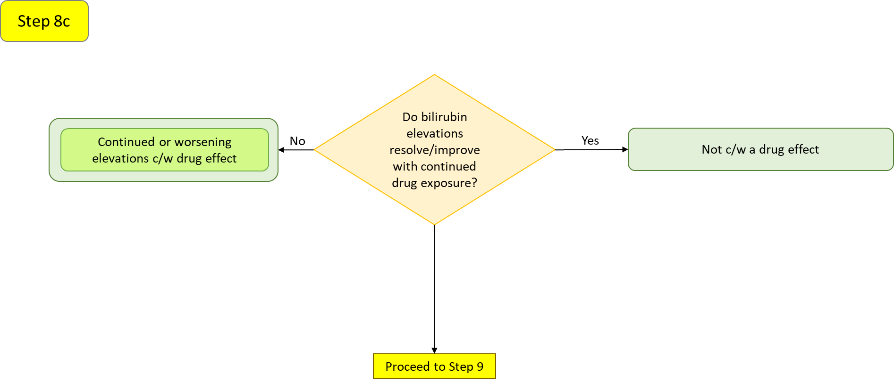

## **Step 8c**

|  |  |
| --- | --- |
| **Do bilirubin elevations resolve/improve with continued drug exposure?** | A drug may initially result in elevations of hepatic analytes, but the elevations may resolve with continued therapy due to adaptation (Shapiro & Lewis 2007, Abboud & Kaplowitz 2007). Alternatively, the abnormalities may have been unrelated to the drug. |

**Additional Considerations**

|  |  |
| --- | --- |
| **Bilirubin fractionation** | Elevations of total bilirubin are generally comprised of conjugated (direct) bilirubin in instances of drug-induced liver injury (Hunt et al. 2007). Total bilirubin elevations principally due to elevations of unconjugated (indirect) bilirubin can arise due to inherited states of decreased bilirubin conjugation by UGT1A1 as in Gilbert’s Syndrome. However, drugs that inhibit conjugating enzymes (OATP1B1 or UGT1A1) or inhibit bilirubin transport can also produce elevations in unconjugated bilirubin. |
| **Extent of hepatic metabolism** | Drugs with eliminated by biliary excretion are more likely to be associated with jaundice (Lammert et al. 2010). |

## **Step 9**

To be implemented in a future version

# **References:**

Abboud G, Kaplowitz N. Drug-induced liver injury. Drug Saf. 2007;30:277-294.

American Gastroenterological Association Clinical Practice Committee. AGA technical review on the evaluation of liver chemistry tests. Gastroenterology 2002;123:1367-1384.

Andrade RJ, Lucena MI, Fernandez MC, et al. Drug-induced liver injury: an analysis of 461 incidences submitted to the Spanish registry over a 10-year period. Gastroenterology 2005;129:512-521.

Avigan M. FDA Guidance on Pre-Marketing Evaluation of DILI: Elements & Ongoing Debatable Issues. Food and Drug Administration/Center for Drug Evaluation and Research-American Association for the Study of Liver Disease-Pharmaceutical Research and Manufacturer’s Association. Hepatotoxicity Steering Group. 25-March-2010.

Bjornsson E, Olsson R. Outcome and prognostic markers in severe drug-induced liver disease. Hepatology 2005;42:481-489.

Chalasani N, Fontana RJ, Bonkovsky HL, et al. Causes, clinical features and outcomes from a prospective study of drug-induced liver injury in the United States. Gastroenterology 2008;135:1924-1934.

Food and Drug Administration. Guidance for Industry - Drug-Induced Liver Injury: Premarketing Clinical Evaluation. July 2009. <https://www.fda.gov/downloads/guidances/UCM174090.pdf>

Green RM, Flamm S. AGA technical review on the evaluation of liver chemistry tests. Gastroenterology 2002;12:1367-1384.

Hunt CM, Papay JI, Edwards RI, et al. Monitoring liver safety in drug development: the GSK experience. Reg Toxicol Pharmacol. 2007;49:90-100.

Kullak-Ublick GA, Andrade RJ, Merz M, et al. Drug-induced liver injury: recent advances in diagnosis and risk assessment. Gut 2017;66:1154-1164.

Lammert C, Bjornsson E, Niklasson A, Chalasani N. Oral medications with significant hepatic metabolism at higher risk for hepatic adverse events. Hepatology 2010;51:615-620.

Leise MD, Poterucha JJ, Talwalkar JA. Drug-induced liver injury. Mayo Clin Proc. 2014;89:95-106.

Lin X, Parks D, Painter J, et al. Validation of multivariate outlier detection analyses used to identify potential drug-induced liver injury in clinical trial populations. Drug Safety 2012;35:865-875.

Merz M, Lee KR, Kullak-Ublick GA, et al. Methodology to assess clinical liver safety data. Drug Safety 2014;37(Suppl 1):S33-S45.

Moylen CA, Suzuki A, Papay JI, et al. A pre-market ALT signal predicts post-marketing liver safety. Reg Toxicol Pharmacol. 2012;63:433-439.

Ozer JS, Chetty R, Kenna G, et al. Enhancing the utility of alanine aminotransferase as a reference standard biomarker for drug-induced liver injury. Reg Toxicol Pharmacol. 2010;56:237-246.

Parks D, Lin X, Painter JL, et al. A proposed modification to Hy’s law and Edish criteria in oncology clinical trials using aggregated historical data. Pharmacoepidemiol Drug Saf. 2013;22:571-578.

Robles-Diaz M, Lucena MI, Kaplowitz N, et al. Use of Hy’s Law and a new composite algorithm to predict acute liver failure in patients with drug-induced liver injury. Gastroenterology 2014;147:109-118.

Senior JR. Evolution of the Food and Drug Administration approach to liver safety assessment for new drugs: current status and challenges. Drug Safety 2014;37 (Suppl 1):S9-17.

Shapiro MA, Lewis JH. Causality assessment of drug-induced hepatoxicity: promises and pitfalls. Clin Liver Dis. 2007;11:477-505.

Thapa BR, Walia A. Liver function tests and their interpretation. Indian J Pediatr. 2007;74:663-671.

Woreta TA, Alqahtani SA. Evaluation of abnormal liver tests. Med Clin N Am. 2014;98:1-16.

Yang X, Schnackenberg LK, Shi Q, Salminen WF. Hepatic toxicity biomarkers. In, Biomarkers in Toxicology, R. Gupta (Ed), Elsevier Inc. 2014; pp. 241-259.

Zimmerman HJ. Hepatotoxicity: The Adverse Effects of Drugs and Other Chemicals on the Liver. Appleton-Century-Crofts, New York, 1978.